COMPREHENSIVE PROFILE EDITING GUIDELINES

INDEX:

EDITING YOUR PEOPLE PROFILE PAGE

LOGGING IN

CHANGING LOGIN INFORMATION

CHANGING THE “ABOUT US” TEXT AND PHOTO

FABI GROUP MEMBER

TEXT AREAS

FILES, LINKS AND RESEARCG PROFILES

PUBLICATIONS

IMPORTANT INFORMATION WILL BE HILIGHTED IN RED

EDITING YOUR PEOPLE PROFILE PAGE:

- The new FABI website allows every user to edit his/her own profile page. This does not require the user to have any coding knowledge or be familiar with HTML coding. However, a few basic principles apply:

- Make sure that any text that is being copied does not contain special characters or fonts. If text is copied from a WORD document for example, first copy it to notepad before copying it to the website. This will remove any special characters or fonts that will not display correctly online.
- When uploading images or photos, make sure they are small and in jpg format. Typically images taken from a digital camera are large in size and should be reduced before uploading them on the website. One easy way to reduce the image size (in Windows) is to right lick on the image and select the ‘send to’ – ‘mail Recipient’ function. Windows will then allow you to reduce the image size (smallest is good enough) and open a new email message with the reduced images attached. The reduced size images can then be saved back to the computer from there.
- Please give all files uploaded appropriate file names. This will help search engines find the necessary information. Make sure that there are no spaces or special characters in the file names. For example, replace spaces in file names with underscores - ‘_’. For example: wilhelm_ophiostoma.jpg.
- When making changes or saving information, please refresh the page to view the changes that you have made by either click on the “refresh” button in the browser or by pressing the “F5” key.

LOGGING IN:
- The login link can be found at the bottom of the page.
- Every FABI member on the FABI mailing list has been registered on the website.

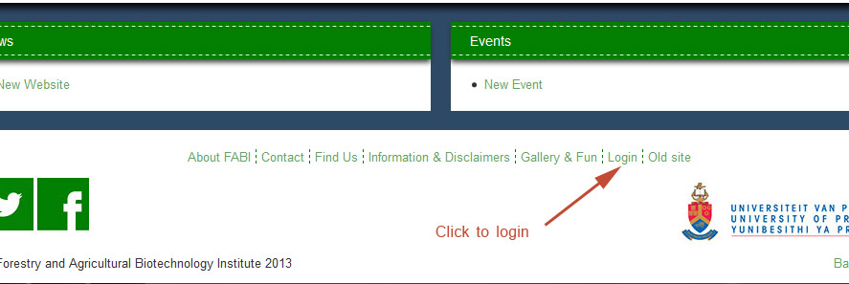

- The username to log into your profile is your FABI email address and default password is 123456 .
- When logged in, you will be directed to your own profile page with all the editing features available. If you have navigated away from your profile page, you can return to the editing page by clicking on the ‘Edit Profile’ link in the profile management box at the bottom of the page.

CHANGING LOGIN INFORMATION:
- When logged into the system, you may change your basic information and login passwords in the profile management box.
- You are able to make changes to your name, password and alternative email address.
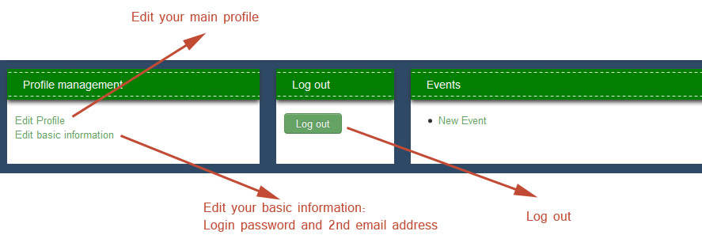
The alternative email address will be used to send you a password reminder. You cannot make changes to your login email address. If required, please ask Heidi Roos to make the necessary changes.
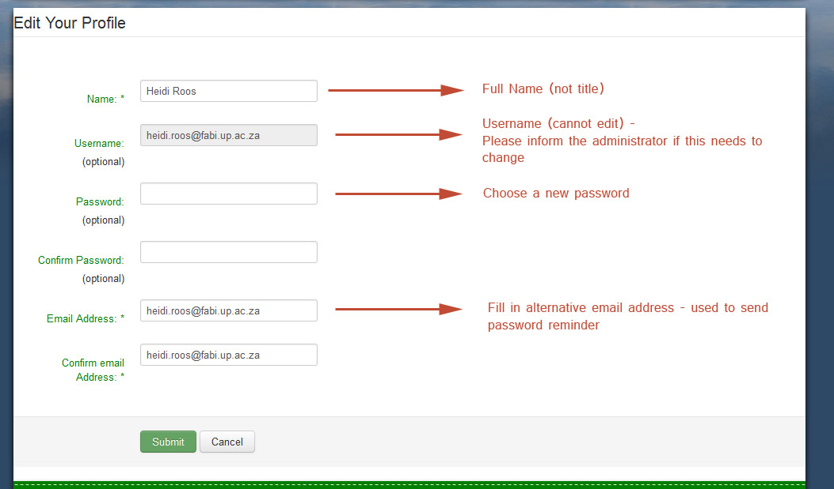

CHANGING THE “ABOUT US” TEXT AND PHOTO:
- By default, all the information on the profile will be empty when logged in for the first time. Click on the ‘Edit About’ button to make changes to your “About” text, profile photo, bio sketch, Short CV or Long CV.
- The “About” text refers to a short paragraph about yourself.
- The basic editor will provide you with all necessary basic editing capabilities.
- If the content is copied into the editor from a WORD document, please first copy it to Notepad and then into the editor online.
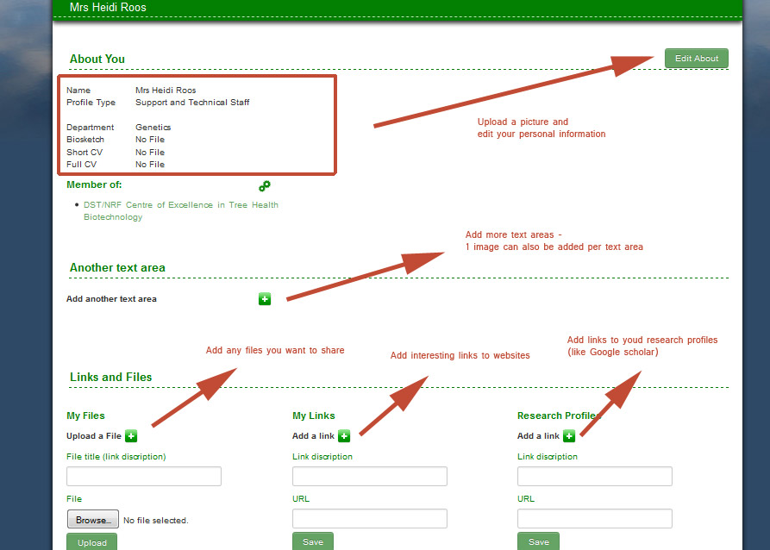

When uploading a photo, preferably choose a portrait oriented picture instead of a landscaped one. This displays better and makes better use of the available place on your profile. Please make sure that the photo is a good quality, close up face portrait because it will be used as a thumbnail picture as well. The system will automatically resize the photo and fit it into the space. Make sure that the file size is not too large.
Although uploading a Biosketch, small CV and Full CV is not necessary, it completes the profile page nicely.

FABI GROUP MEMBER:
- Every FABI person may belong to one or multiple groups within FABI.
- To edit the groups that you belong to, you may click on the editing icon (two small cogs) next to the ‘Member of’ heading. You will be directed to a new page where you may be assigned to multiple groups. The Role text area refers to the role that you have inside the group. This is not a mandatory text field.
- Click on the back button in the top right corner to get back to the profile editing page.
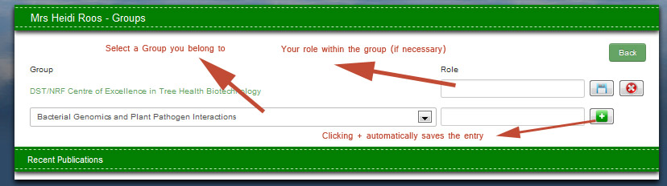

TEXT AREAS:
- Multiple text areas may be added in addition to the already available ‘About’ text. Every text area has a heading, content and may contain one picture placed at the top of the text, inside the text - on the right hand side and at the bottom of the text.
- Add a text area by clicking on the ‘+’ button. A text title dropdown box will appear with some suggested titles or a customised title. After choosing a title, click on ‘Add Text Area’. The title will appear on the right in a grey block, which can be clicked on to display the edit button. Editing the text will allow you to edit the content (in a similar way to the ‘about’ text) as well as allowing you to add an optional picture to the text area. There are three positions that the picture can be relative to the text. When done, click on save text.

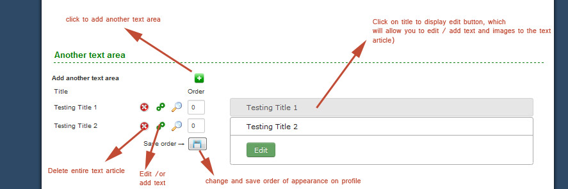

FILES, LINKS and RESEARCH PROFILES:
The Files, Links and Research profiles may be used for anything that needs to be shared. There is no restriction to what can be uploaded or what links can be submitted.
- My Files – May be used for sharing any files, documents or information you want publically visible
- My Links – Any links to websites or external links on the internet that you would like to publically share. The link will display as clickable text.
- Research profiles – A link to your external research profiles. This includes Google scholar or Research gate profile. When inserting the link, visit the actual page first and copy and paste the link into your FABI profile to avoid mistakes.

- It is important however to include the http:// to the link. I.e. When saving a URL (for example http://www.google.co.za) make sure to include the http:// . The easiest way to do this is to copy the link when visiting the page and then pasting it into the field.

PUBLICATIONS

The FABI site allows all members to upload publications on behalf of someone or for themselves. Three different publication types are available: Journal article, Book chapter and Book.
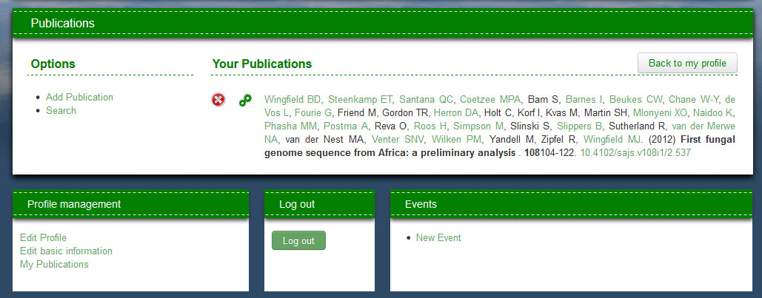

Adding a publication:

Depending on the type of Publication that gets added, certain information fields are available. Except for the title, none of these fields are required. By holding your mouse curser over the heading of the field label an information popup will appear with the short label of the field corresponding to the label that may be found when exporting publications to RIS format.
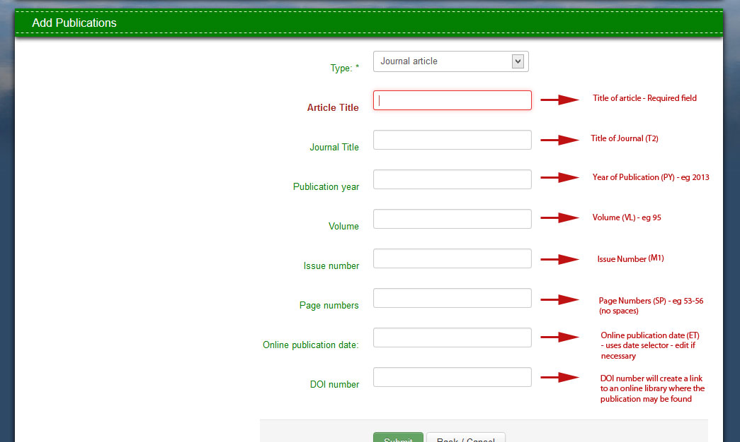

When done and clicking submit, the user will be required to link all the authors to the publication. The publication will appear on every linked FABI author’s profile page. i.e. only one person needs to upload a publication and every person linked to the publication will automatically also see the publication on his/her profile page.
Its also possible to upload publications on behalf of other people. The system displays the publications on all the profile pages of authors that are linked. So, make sure to include yourself as an author if you are part of the publication. Otherwise the system will not display the publication on your own profile page.

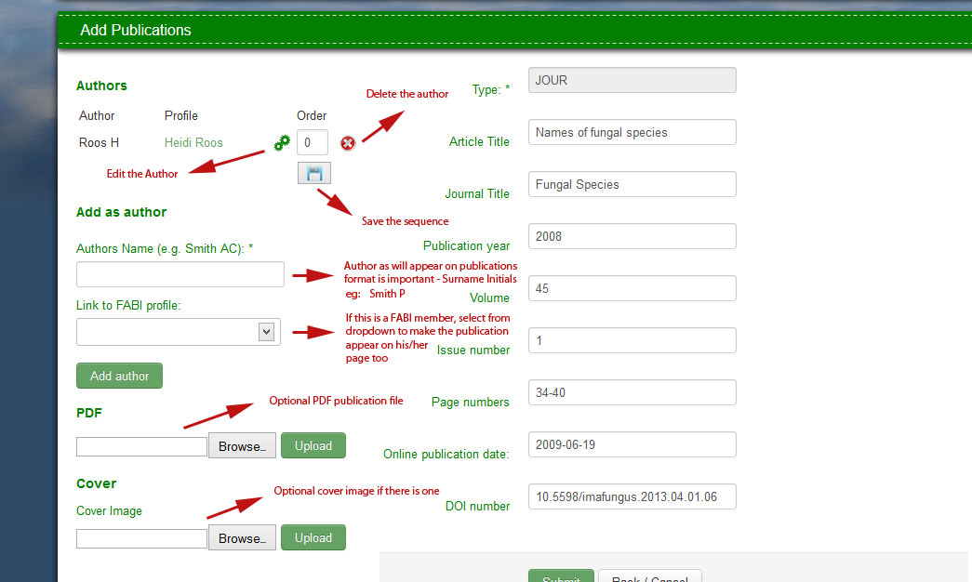
Publications already added may only be deleted by an author. Any FABI member can edit any publication. This is necessary as someone may have to add himself/herself as an author. We keep a log who edited publications in case this feature is misused.

